## Task 1: Create S3 Bucket

1. Make sure you are in the US East (N. Virginia) us-east-1 Region.
2. Navigate to the  menu at the top. Click on S3 in the Storage section.
3. On the S3 Page, click on and fill in the bucket details.
   * Bucket name :Enter *mys3bucket-test*
     + Note: S3 bucket name is globally unique, choose a name which is available.
   * Region: Select US East (N. Virginia) us-east-1
   * For Object ownership: Select ACLs enabled
     + Object ownership option: Choose Object writer  
       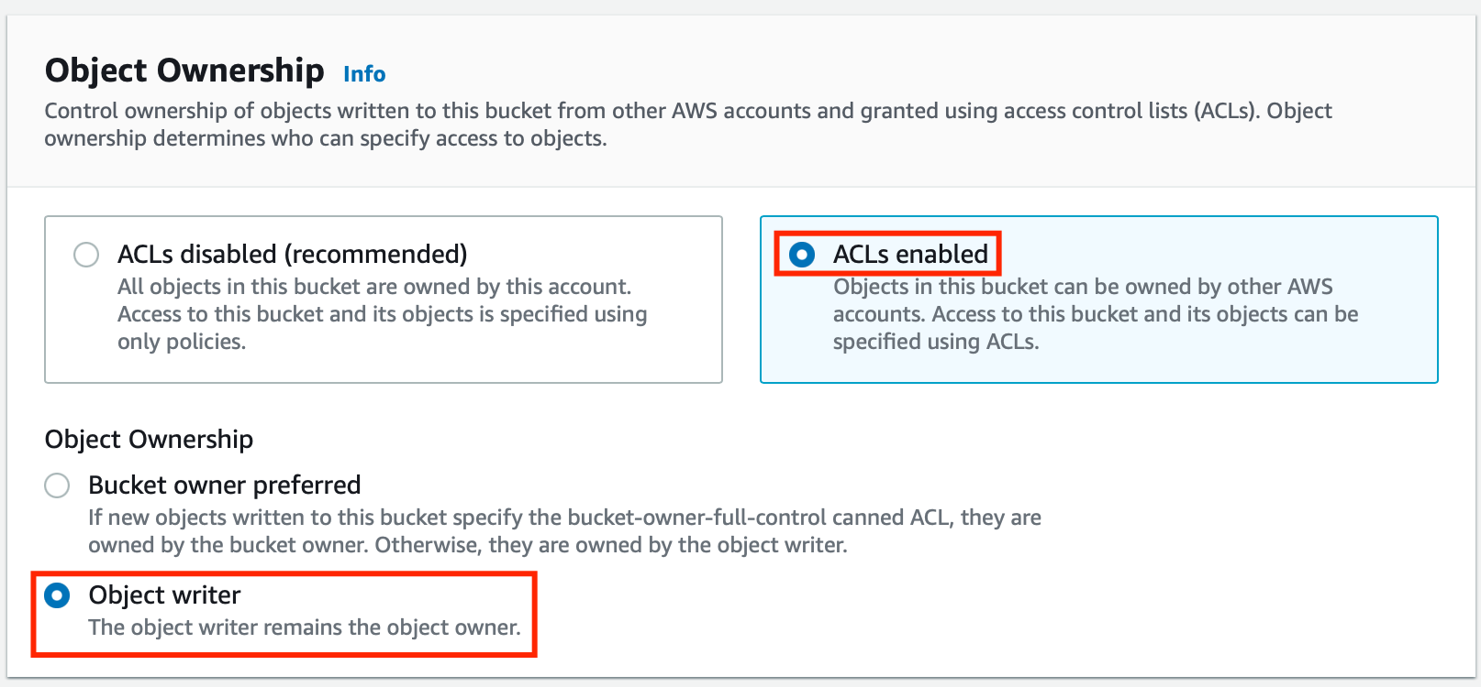
   * Note: Please select Object owner, else it won't allow editing the bucket ACL.
   * For Block Public Access settings for this bucket section,
     + Uncheck the option, Block all public access, and check the acknowledge option.  
       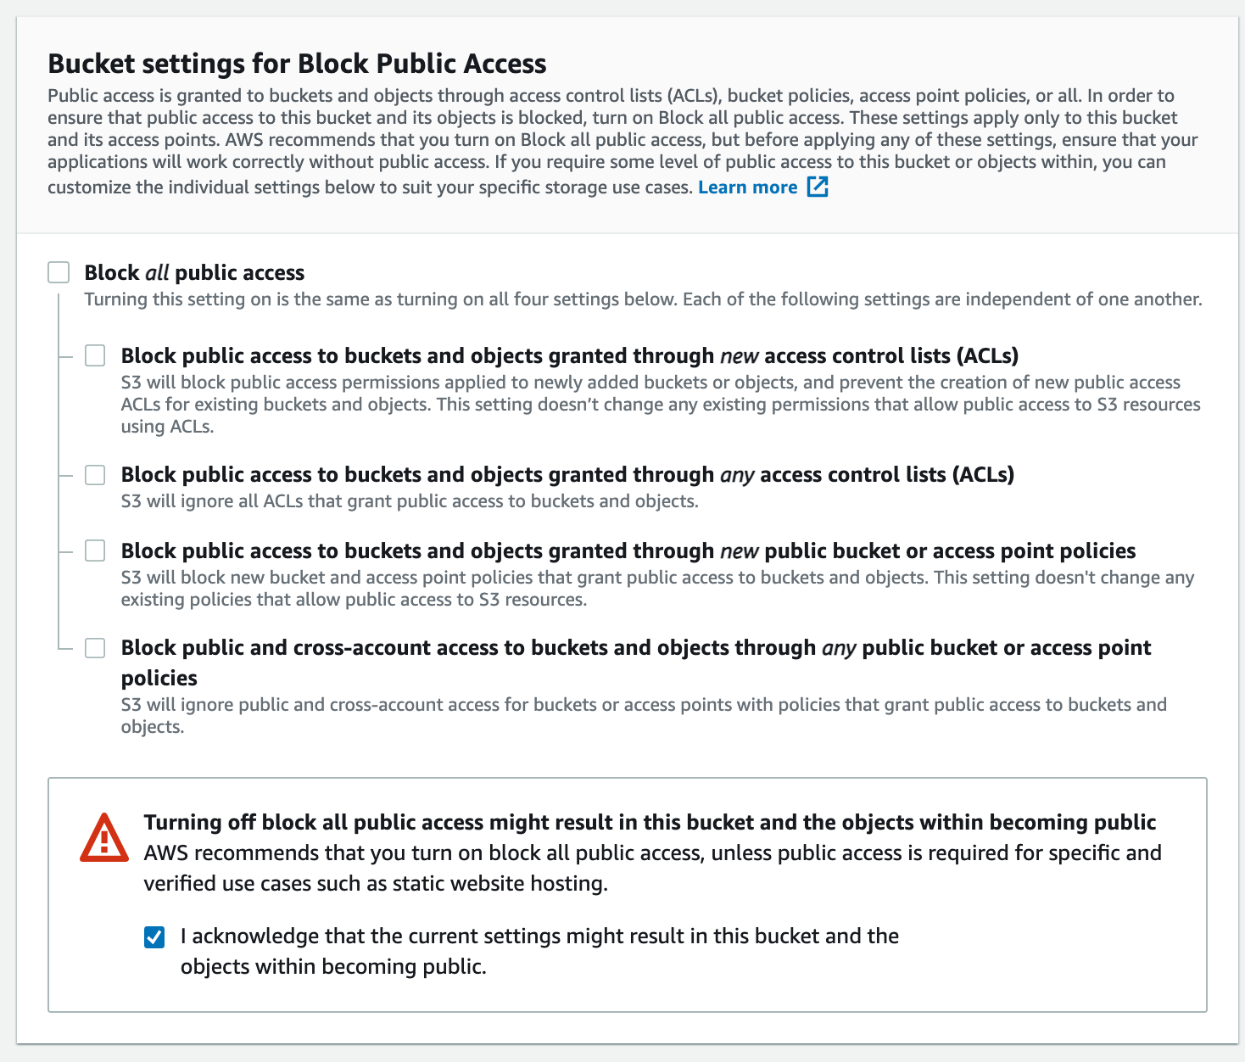
   * Leave other settings as default.
   * Click on  button.

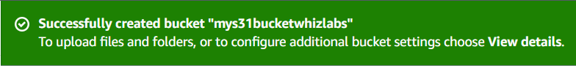

1. The S3 bucket is created.

## Task 2: Upload an object to S3 bucket

1. Click on your bucket name.
2. In the Overview, You can see the following message
   * You don't have any objects in this bucket.

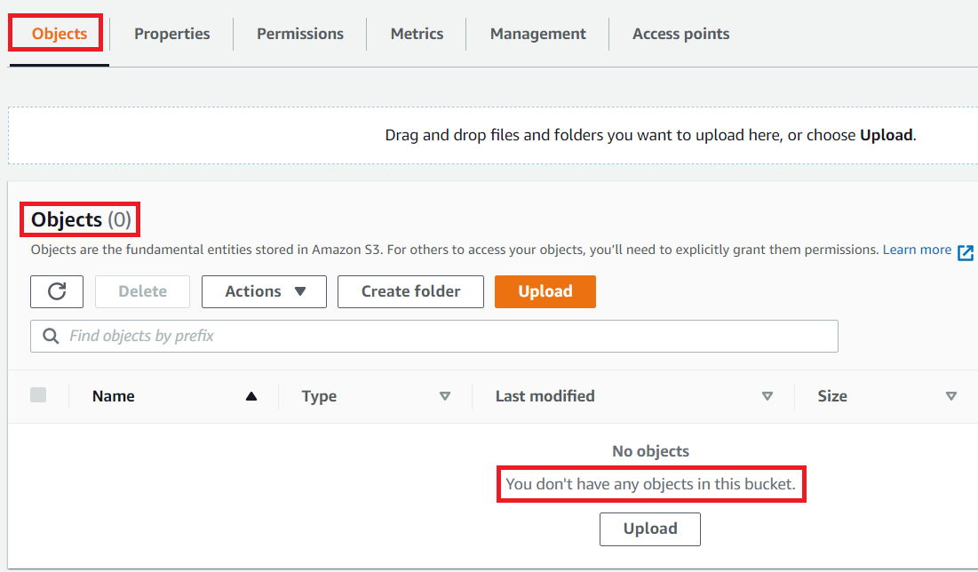

1. You can upload any image from your local machine
2. To upload a file to our S3 bucket,
   * Click on Upload button.
   * Click on 
   * Browse for your local image or the image we provided and select it.
   * Click on the  button.
   * You can watch the progress of the upload from within the transfer panel at the top of the screen.
   * Once your file has been uploaded, it will be displayed in the bucket.

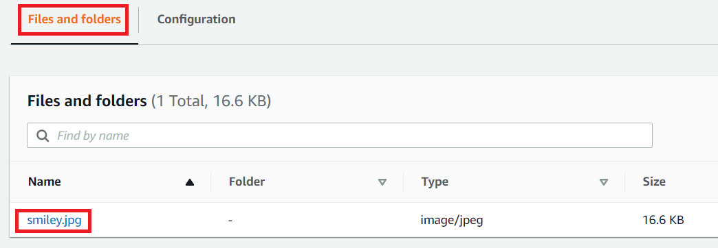

1. Now click on the Close button on the top right corner of the screen.

## Task 3: Change Bucket Permissions

Change the permissions of the bucket to make he image available publically.

1. Under Objects, Click on smiley.jpg, You will see image details like owner, size, link, etc.
2. A URL will be listed under Object URL
3. Open image Link in a new tab.
   * You will see an AccessDenied message, which means the object is not publicly accessible.

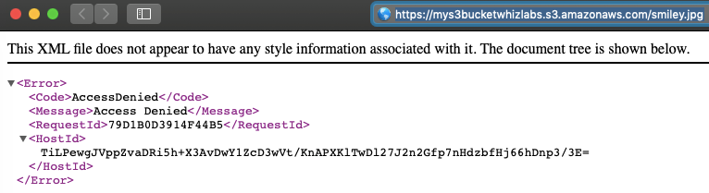

1. Go to your smiley.jpg object and navigate to the Permissions tab.

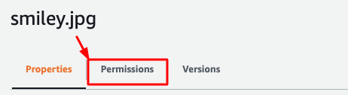

1. Now click on the  button on the right side.
2. Note: If the Edit button is disabled, please change the bucket ownership to ACLs enabled and choose object writer as the owner.
3. Everyone (public access) : check the Read checkbox of Objects.

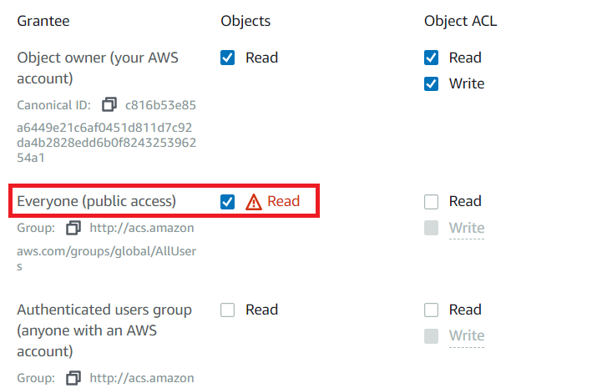

1. Now scroll a little bit below and check I understand the effects of these changes on this object. Checkbox.

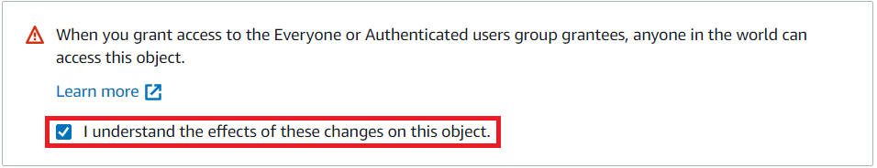

1. Now Scroll to the bottom and click on  button,
2. Now again Open image Object URL in a new tab and you will see the Smiley image in your browser..



## Task 4: Create a Bucket Policy (Optional)

1. In the previous step, you granted read access only to a specific object. If you wish to make all objects inside a bucket available publicly, you can achieve this by creating a Bucket policy.
2. Go to the bucket by clicking on your bucket name - mys3bucket on the top.
3. Click the  tab, then configure the following
   * Scroll down to  , click on  button on the Right side.
   * A blank Bucket policy editor is displayed.
   * Copy the ARN of your bucket to the clipboard.
     + arn:aws:s3:::mys3bucket-test
4. Copy the entire policy, paste it in the bucket policy and replace your bucket ARN with the ARN listed in the JSON below.

| {  "Id": "Policy1",  "Version": "2012-10-17",  "Statement": [  {  "Sid": "Stmt1",  "Action": [  "s3:GetObject"  ],  "Effect": "Allow",  "Resource": "replace-this-string-from-your-bucket-arn/*",  "Principal": "*"  }  ]  } |
| --- |

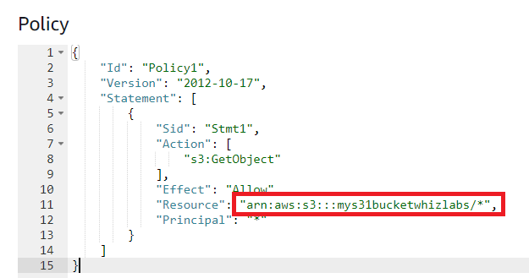

* Click on  button.

## Task 5: Test Public Access

1. Upload another image
   * Click on Upload button.
   * Click on 
   * Browse for your local image or the image we provided and select it.
   * Click on the  button.
2. Once the image is uploaded successfully, click on the object name (Image name) , copy the image URL and open it in a browser.
   * https://whizlabsresources.s3.amazonaws.com/image.png
3. You can see your image loaded successfully and is publicly accessible.